UI UX
DOMAIN : Real Estate
WEBSITES :




Housing.com Bayut


MahaRERA SquareYards

• Housing.com

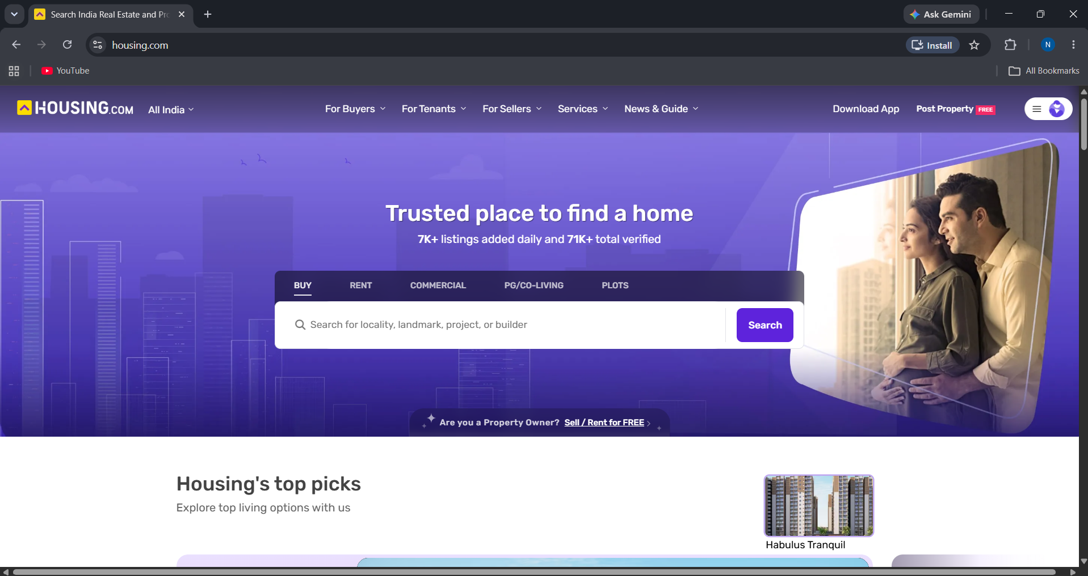

• Bayut- Dubai real estate

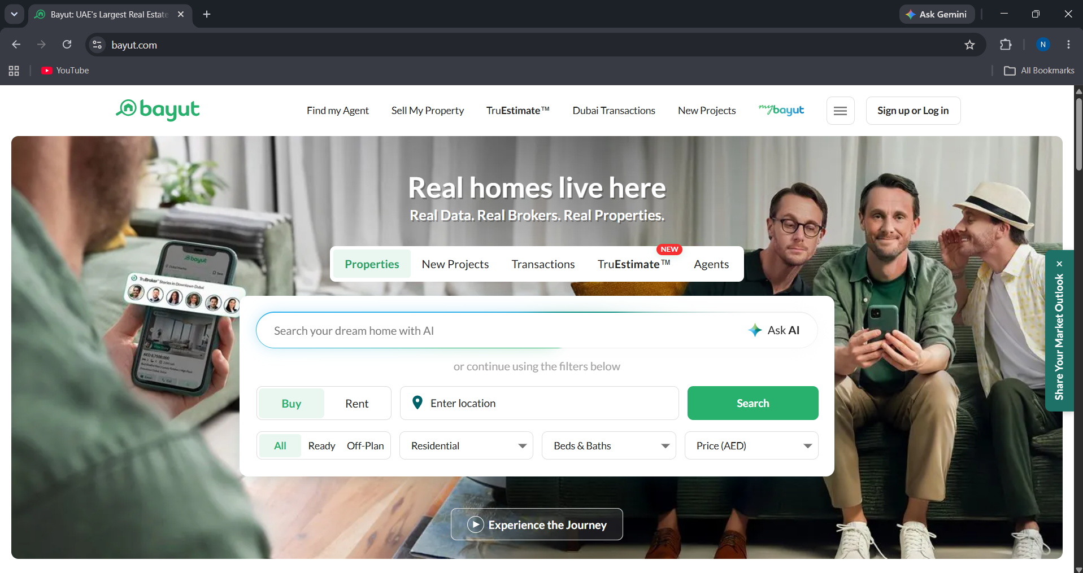

• MahaRERA- Maharashtra govt. website

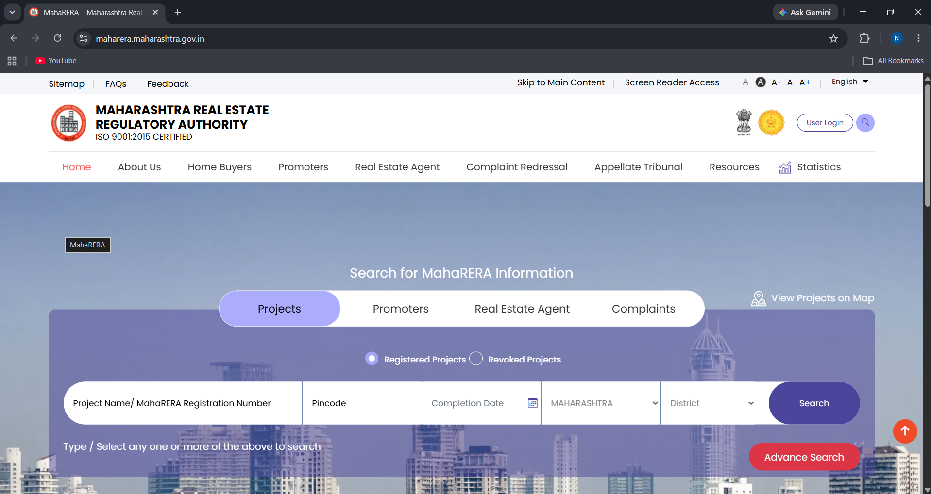

• Square Yards- specifically Pune

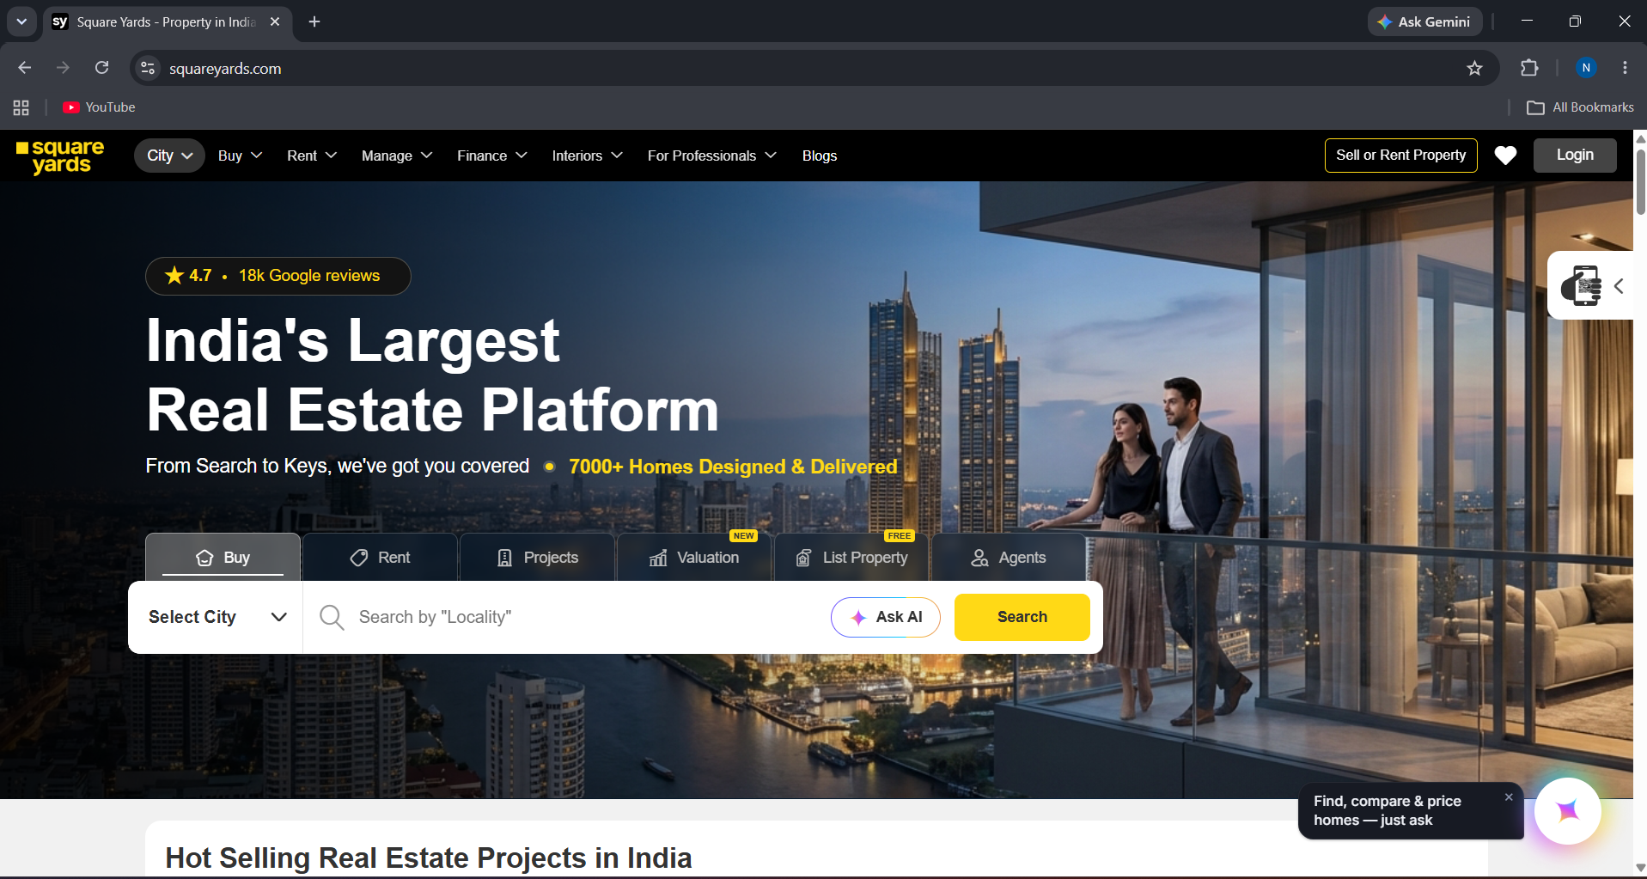

NAME: Nancy Kathiriya
PRN: 1262242543
ROLL NO: 13
PANEL: F

PROBLEM STATEMENT-
Critical Analysis of Interfaces: Analyse any one interface (website or mobile app) that you have interacted with that could be designed better. Focus on the interface design problems, rather than their engineering faults or business problems. Comment on its learnability, usability, consistency and metaphors.
Interface Analysis
Housing.com:
Housing.com provides a modern and relatively easy-to-understand property-search interface. Its clear categories, property cards and filters support learnability and usability. However, the large amount of information and promotional content on some pages can make the interface feel crowded.
Bayut:
Bayut provides the strongest overall interface among the four websites. Its search, filters, map-based discovery and property cards are easy to understand and consistent. However, the large number of features and options can sometimes increase the amount of information users need to process.
MahaRERA:
MahaRERA is primarily designed for real-estate regulation and property verification. It provides strong credibility and useful search and verification functions. However, its form-heavy structure, dense information and regulatory terminology can make it less learnable for first-time users.
SquareYards:
SquareYards offers a wide range of real-estate services including buying, renting, projects, valuation and agents. Its interface is generally consistent and visually appealing. However, the large number of features and information can increase cognitive load and make navigation more complex.

Overall Observation
Among the four interfaces, Bayut provides the best overall balance of learnability, usability, consistency and visual design. Housing.com follows closely with a strong and simple property-discovery experience. SquareYards provides more services but can feel information-heavy, while MahaRERA is strongest for trust and verification but requires more effort to learn and navigate.

CHATGPT VERSION
Housing.com vs Bayut vs MahaRERA vs SquareYards
Parameter | Housing.com | Bayut | MahaRERA | SquareYards
Learnability |  | Simple search and property cards make the interface easy to understand. | Regulatory terms and many options can confuse new users. | Main categories are clear, but many services require more exploration.
  Clear search and property categories make it easy for first-time users.
Usability |  | Excellent search, filters and map tools make property discovery easy. | Useful for project and agent verification, but less convenient for browsing. | Good property search with projects, valuation and agent services.
  Smooth property search with useful filters and saved properties.
Consistency |  | Strong consistency across cards, icons and navigation. | Forms and layouts are consistent but look more functional. | Consistent cards, search controls and navigation throughout.
  Cards, buttons and filters follow a consistent design.
Use of Metaphors | Familiar search, map and save icons are easy to understand. | Map pins, save icons and property cards are intuitive. | Uses basic search and document concepts with fewer visual metaphors. | Uses familiar search, map, shortlist and calculator concepts.
Navigation Structure | Buy, Rent and Projects are clearly organized. | Clear navigation for properties, projects and agents. | Many regulatory sections make navigation more complex. | Clear categories, but the large number of services adds complexity.
Visual Hierarchy | Property images, prices and search tools receive good emphasis. | Search, property images and prices have strong visual priority. | Forms and official information dominate the visual layout. | Search and project cards are prominent but pages can feel busy.
Accessibility | Readable typography and structured content support accessibility. | Clear layouts and controls provide good accessibility. | Dense text and forms can make the interface harder to use. | Generally readable, but complex filters can be improved.
Responsiveness | Works well across desktop and mobile screens. | Strong responsive experience across devices. | Responsive, but forms and tables are less comfortable on mobile. | Property listings adapt well to different screen sizes.
Efficiency of Interaction | Filters and saved searches reduce unnecessary steps. | Advanced filters and maps make interaction highly efficient. | Efficient for verification after users understand the process. | Search, filters and valuation tools reduce user effort.
Feedback & System Status | Search results and saved properties provide useful feedback. | Clear listing status and search feedback. | Forms and search results provide basic status feedback. | Search results and property status provide adequate feedback.
Error Prevention & Recovery | Structured filters help prevent common search errors. | Detailed filters and inputs reduce user mistakes. | Form validation helps prevent important errors. | Filters prevent common errors, but complex options may confuse users.
Aesthetic & Minimalist Design | Modern property images and cards create an attractive interface. | Polished visuals and spacious cards create a premium feel. | Functional design focuses more on information than aesthetics. | Modern design, but many services make pages visually busy.
Content Readability | Property prices, BHK and details are easy to scan. | Property information is clearly organized in cards. | Legal and regulatory information is more difficult to scan. | Information is clear but can become dense.
Search & Discoverability | Strong filters for location, price, BHK and property type. | Excellent search with advanced filters, maps and AI features. | Strong search for projects, agents and complaints. | Strong search by location, budget and property type.
Performance Perception | Generally responsive, though image-heavy pages may feel slower. | Feels fast and smooth during property discovery. | Text-heavy pages can feel less fluid. | Highest institutional trust due to its official regulatory role.
Trust & Credibility | Verified listings and detailed information build trust. | Agent, property and market information support credibility. | Highest institutional trust due to its official regulatory role. | Developer, project and property information build credibility.
Personalization | Saved properties, searches and alerts provide personalization. | AI search, saved searches and recommendations improve personalization. | Limited personalization due to its regulatory purpose. | Saved properties and AI-assisted discovery provide personalization.
User Satisfaction | Strong balance of search, visuals and property information. | High satisfaction due to polished design and powerful search tools. | Highly useful for verification but less engaging as a marketplace. | Good satisfaction due to its wide range of real-estate services.

LEARNABILITY
How quickly a new user understands the interface.
Website | Rating | Points
Housing.com | 9/10 | - Clear Buy, Rent and Projects options.  - Search and filters are easy to understand.  - Property cards make information easy for new users to recognize.
Bayut | 9/10 | - Simple search and location-based browsing.  - Property cards and filters are familiar.  - Map-based search is easy to understand.
MahaRERA | 6/10 | - Regulatory terminology can be difficult for beginners.  - Many forms and options require understanding.  - Mainly designed for users looking for official information.
SquareYards | 8/10 | - Main Buy, Rent and Projects sections are clear.  - Search is easy to start.  - Many additional services require more exploration.

USABILITY
The ease with which users can complete travel-related tasks efficiently.
Website | Rating | Points
Housing.com | 9/10 | - Searching and filtering properties is straightforward.  - Users can save and compare properties.  - Property details are presented clearly.
Bayut | 9/10 | - Advanced filters make searching efficient.  - Map and list views support quick discovery.  - Property and agent information is easy to access.
MahaRERA | 8/10 | - Useful for checking projects and agents.  - Search tools support verification tasks.  - Less convenient for general property browsing.
SquareYards | 9/10 | - Provides property, project and agent searches.  - Valuation and other tools improve usefulness.  - Many services are available from one platform.

ERROR PREVENTION AND RECOVERY
How well the interface helps users avoid mistakes and recover from them.
Website | Rating | Points
Housing.com | 8/10
  - Structured filters reduce incorrect searches.
  - Search options help users narrow results.
  - Some complex searches may require corrections.
Bayut | 9/10 | - Detailed filters help prevent incorrect results.  - Structured search fields reduce mistakes.  - Clear property categories support recovery.
MahaRERA | 8/10
  - Structured forms help users enter information correctly.
  - Validation supports important verification tasks.
  - Complex terminology can still cause confusion.
SquareYards | 8/10 | - Filters help narrow down searches.  - Structured property information reduces mistakes.  - Large numbers of options can sometimes confuse users.
USE OF METAPHORS
Using familiar real-world icons and symbols to help users understand and navigate the interface easily.
Website | Rating | Points
Housing.com | 8/10 | - Search, map and save icons are familiar.  - Property cards represent real-world property information clearly.  - Familiar icons reduce the learning effort.
Bayut | 9/10
  - Map pins immediately represent locations.
  - Heart/save icons are familiar to users.
  - Property cards and search icons are intuitive.
MahaRERA | 7/10 | - Search and document concepts are recognizable.  - Forms reflect real-world registration processes.  - Uses fewer visual metaphors than marketplace websites.
SquareYards | 8/10 | - Search and map icons are easy to understand.  - Shortlist/save concepts are familiar.  - Calculator/valuation tools represent their functions clearly.

8 GOLDEN RULES OF INTERFACE DESIGN
Golden Rule | Housing.com | Bayut | MahaRERA | SquareYards
1. Strive for consistency | Consistent cards, buttons and filters. | Strong consistency across pages and components. | Consistent forms but more traditional design. | Consistent navigation and property cards.
2. Seek universal usability | Easy for most property-search users. | Simple core search with advanced options. | More difficult for first-time users. | Useful for different real-estate needs.
3. Offer informative feedback | Search and saved-property actions provide feedback. | Clear search and listing status feedback. | Forms and search results provide basic feedback. | Search and property tools provide useful feedback.
4. Design dialogs to yield closure | Property selection and contact flows are clear. | Search and property actions have clear outcomes. | Verification processes provide results after submission. | Search and valuation tools show clear results.
5. Prevent errors | Filters reduce incorrect property searches. | Detailed filters prevent many search mistakes. | Form validation helps prevent important errors. | Structured filters reduce common mistakes.
6. Permit easy reversal of actions | Users can change filters and searches easily. | Filters and search criteria can be modified easily. | Forms may require more effort to change. | Search and filter choices can be changed easily.
7. Keep users in control | Users control filters, searches and saved listings. | Strong control over location, price and property filters. | Users follow more structured regulatory processes. | Users can choose between many property services.
8. Reduce short-term memory load | Property cards show important details together. | Search filters and cards reduce information recall. | Users may need to remember terms and procedures. | Multiple tools and options can increase memory load.

THANK YOU

